|  |  |
| --- | --- |
|  |  |

Ericsson Catalog Manager Business Guide

Contents

1 Abstract 2

2 Market Situation 3

2.1 Market Background 3

2.2 Current Market Situation 5

2.3 Market Potential and Market Trends 6

3 Target Customer 8

4 Our Offering 10

4.1 Description 10

4.2 Customer’s Business Environment 14

4.3 Pricing Principles 14

5 Customer Benefits and Value Argumentation 15

5.1 Market Message 15

5.2 Value Argumentation 17

5.3 Business Case 20

6 Sales Approach 22

6.1 Sales and Differentiation Strategy 22

6.2 Customer communication 23

6.2.1 If you only have 10 seconds, say this: 23

6.2.2 If you have 10 minutes, say this: 23

6.2.3 If you have one hour, say this: 24

6.3 Sales activities 24

6.4 Tactical Aspects 24

7 Customer Project Approach 25

8 Competitive Situation 26

# Abstract

In today’s competitive market, both fixed and mobile operators must reduce the time and complexity of launching a wide array of innovative and complex new product offerings, including those that involve third parties. A central product catalog solution is the first step in enabling the operator to achieve true product convergence. Taking an end-to-end perspective − rather than deploying isolated product stacks − enables lead-to-cash transformation making the implementation more effective for both the short and long-term.

Ericsson Catalog Manager provides the foundation for transformation through a centralized catalog that:

* Defines the commercial aspects of the product and the more technical service and resource aspects needed to fulfill a request.
* Enables assembly and reuse of proven product components throughout the lifecycle of product offerings.
* Allows customer service representatives (CSRs), third-party channels and self-care portals to offer relevant services to customers, bundled into a single quote.
* Drives efficiency in fulfillment, charging and assurance through real-time delivery of product information and relevant workflows to downstream systems.

This means that operators can reduce the time to market new product offers by using a catalog-driven approach that promotes the reuse of proven components to reliably automate offer assembly. A catalog-driven approach to service delivery enables business process automation and reduces order processing delays for in-house services as well as those involving third-party service partners. Operators can reduce the time to architect each third-party relationship by leveraging consistent data exchange, business process handling and provisioning methods. And operators can decrease service order fallout by enforcing a more consistent structuring of product offers and automation of fulfillment processes.

With a more consistent structuring of product offerings and automation of product selection, operators can also improve their customer’s experience by providing relevant product solutions to meet customer requirements. The entire pre-order process provides more reliable commitments. Detailed product recommendations ensure fewer errors during quote-to-order and on-time delivery with less customer callbacks.

When introducing new products, the development time and effort can be significantly reduced by enabling process federation over multiple fulfillment stacks, by using and reusing service components, and through flexible modeling and more consistent data, processes and methodologies.

Unlike its competitors, the Ericsson solution results in faster time to market by promoting component reuse. It combines a well-structured set of product/service/resource components with related fulfillment processes to reduce the time to introduce new products and respond to changing third-party needs. The Ericsson solution makes product offering data available to OSS/BSS across federated domains, reducing provisioning complexity and making offers more readily available to external parties. It maximizes flow-through of customer orders that involve product partners by providing a well-structured set of proven product/service/resource components and related fulfillment work flows. It also enables third parties to develop their own hybrid solutions with processes already built-in.

Driving the entire product lifecycle chain from a single application federates and harmonizes data to the composite applications. Defining products from an end-to-end perspective – and using the catalog in the various stages of the lead-to-cash cycle – relieves the pain points of dynamic pricing and order decomposition.

With a component-based approach, the catalog is expressly designed to let the operator centrally define products, pricing rules and quality-of-service requirements, while allowing for configuration and personalization. All of these data elements are automatically propagated to the sales view, billing view and technical services view.

Further, the catalog drives order negotiation in the customer relationship management system, as well as order decomposition and orchestration in the order management system – all in real time.

In this changing digital world involving fluid products that rely on a fabric of multiple suppliers and partners, pain points surrounding product creation and delivery are not something that operators have to live with. With a component-enabled catalog and robust solution methodology, they will have a solution that not only relieves but can also eliminate the trauma.

# Market Situation

## Market Background

Operators are in a highly competitive and saturated market where time to market for new product introduction should be fast-paced but how do they lower the commercial risks, enable differentiation and gain better customer acceptance for their product offers in order to improve revenues?

Operators typically face significant OSS/BSS/SDP challenges in introducing many new or increasingly complex product offers. Each introduction usually requires custom development that delays time to market. The introduction of new products may also require updates to legacy OSS/BSS making the introduction and delivery costly and painful.

Operators need to improve the manner in which products are created and the ordering of these products. Customers increasingly expect to place self-serve orders without time consuming delays waiting for network placement or install. They want to configure their own feature list or create their own bundles – requiring the operator to be more flexible in their customer-facing ordering capabilities. Product offerings may also be distributed through new channels, e.g. offerings made available by an over-the-top vendor or a non-telco device (machine-to-machine).

Operators also need to improve both their business-to-consumer (B2C) and business-to-business (B2B) interactions to improve the value chain. How is a catalog utilized/managed in complex value chains? For example, the drive to provide a mashed-up product offer from multiple supplier/partners is causing the operator to re-invent the way their products and services can be exposed to outside parties. This exposure of product/service/resource offers requires improved and standardized interactions. Another example might be a complex value chain where the final product offering sold to the consumer is dynamically assembled from multiple partners and priced at the time of the order.

The current approach of dealing with product complexity usually results in limited process automation, complex B2C/B2B information exchanges and slow time to market.

Current order-to-cash platforms are not properly structured to automate, and orchestrate the processing of increasingly complex orders. The related processes and data tend to be fragmented and disconnected. This lack of a common platform to federate and orchestrate processes and policies, along with the product/service/resource definitions, is an obstacle to the profitable offering of complex multi-product offers.

Operators need to introduce products/services in as little as weeks, days and/or hours. Delays in time to market are caused by lack of a standardized approach to product/service/resource introduction. Going forward, the act of bringing new products to market will be less and less of a unilateral, internally focused operator process. Product offerings, their technical service and resource requirements and their associated business processes become an asset that can be accessed by third parties as they build offers. Product managers and external developers are looking to operators to provide an environment that allows players up and down the supply chain to innovate in an open and efficient way. The basic building blocks in this “service factory” need to be componentized and standardized into more manageable and more flexible parts that can be used at any point along the supply chain.

## Current Market Situation

In August 2013, Ericsson announced that it had been named the global leader in service fulfillment systems by leading industry analyst firm Analysys Mason, with nearly 12 percent market share (see figure below).

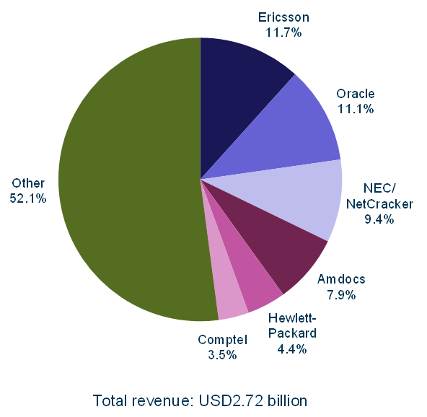

**Figure 1** Service fulfilment market shares by revenue, worldwide, 2012 [Source: Analysys Mason, 2013]

Note that the 2012 ConceptWave revenue is included in the “Other” category, so that the Ericsson total share is even larger than 11.7%.

Note that the Ericsson market share is even higher, at close to 15%, when considering product revenue only (i.e., excluding product-related services revenue). This is due to the fact that our products are more deployment-ready and requires less vendor involvement when compared to our closest competitors, Oracle, NEC and Amdocs.

Also notable earlier in 2013, leading industry analyst firms Gartner and Infonetics Research named Ericsson the worldwide leader in telecom operations management (Market Share Analysis: Telecom Operations Management – BSS, OSS and SDP, Worldwide, 2011-2012, April 29, 2013) and the SDP Vendor of Choice (SDP Strategies and Vendor Leadership: Global Service Provider Survey, June 6,2013), respectively.

Ericsson Catalog Manager and Ericsson Order Care have been deployed at the world’s premier operators across the world. Notable examples are:

* Americas: Time Warner Cable, Charter, Comcast, Bell Canada, Rogers Canada, Verizon, TSTT, Videotron, MTS Allstream, CenturyLink, Telemar (Oi)
* Europe: Belgacom, Portugal Telecom, Swisscom, Turk Telekom, Telecom Italia, BMW, T-Hrvatski Croatia
* Middle East & Asia: CSL Hong Kong, TOT Thailand, Reliance, Saudi Telecom

New deployments include Telecom New Zealand, T-Mobile USA and Ziggo. The Ericsson implementations utilize various features of the Ericsson suite of order management products.

## Market Potential and Market Trends

Specific category breakouts for Catalog Management are not available from industry analysts at this time. Analysys Mason notes that Catalog Management spans two of the areas they track: Order Management (within Fulfillment) and CRM (within Customer Care and Billing). Catalog Management forecasts and markets shares are included (but not double-counted) in each of these two categories. For our purposes, we will briefly refer to the overall Service Fulfillment category and the Order Management segment and point out any related catalog impacts.

**General Service Fulfillment and Order Management Trends**

According to Analysys Mason, key market trends are:

* Service fulfilment projects are primarily driven by opportunities to increase revenue as it enables them to quickly and efficiently implement new services. However, cost reduction will continue to be an important consideration in project approval. *We continue to develop business case analyses that consider both revenue and cost components.*
* In the short term, the service fulfilment market is expected to grow at a higher rate than some other telecoms software segments. Growth will be driven by:
  + network evolution towards optical/packet technology
  + implementation of LTE and self-optimizing networks (SONs)
  + the desire for instant availability of complex service bundles
  + the need to operate in uncertain and changing business environments
  + deregulation of broadband and mobile services in emerging markets
  + the increasing desire to meet the needs of small and medium-sized enterprises
* In the long term, growth will also be driven by the new double-sided business offerings of CSPs, machine-to-machine (M2M) mobile services, cloud computing and storage services, small-scale national broadband infrastructure investment projects and renewed interest in system transformation projects.
* Specifically in terms of Cloud Computing, automated operations are a necessity. CSPs must implement new service fulfilment infrastructure, or extend established ones, to support the reservation and service provisioning needs of its cloud offerings (IaaS and PaaS) to large and medium enterprises. These must be highly automated and under the control of the customers. They must work together with complementary functions in the customer care and billing arenas, sharing a common product catalogue and subscriber data. *Ericsson Catalog Manager is designed to provide end-to-end catalog functionality to all areas of the business.*
* Tier 1 CSPs are increasingly implementing service fulfilment stacks for new services from a single vendor. In fact, two-thirds of order management deals are part of a full service fulfilment stack of systems. *With our #1 position in fulfillment OSS, Ericsson is in an excellent position to offer a comprehensive fulfillment solution.* The trend is also for vendors to deliver order management systems with a product and service catalog. *Ericsson is uniquely qualified with a proven pre-integrated catalog and order management solution.*
* Vendors usually deliver order management systems together with a product and service catalog, because all order management vendors have adopted the catalog-driven approach to order management and order orchestration. In this approach, process fragments are associated with individual product or service items in the catalog and dynamically assembled during execution of the order process. *Ericsson is the market leader in terms of catalog-driven “everything” and other vendors have followed our approach.*

These trends point to the following opportunities:

* Position Ericsson Catalog Manager as part of a comprehensive service fulfillment solution and link it to its active role in driving CRM and billing.
* Highlight industry standards that Ericsson has followed regarding Ericsson Catalog Manager, such as the TM Forum Shared Information Data model (SID) and the Business Process Framework (eTOM).
* Keep an eye on strategic initiatives, such as cloud computing and machine-to-machine (M2M), with emphasis on:
  + Automated operations
  + Open interfaces accessible to third-party systems
  + Ability to quickly support new IT-like services

# Target Customer

In general, Ericsson Catalog Manager is geared towards the needs of Customer Service, Product Management/Marketing, Operations and IT executives who want to enforce a disciplined approach to new product introduction and implement a more consistent structure for fulfilling product orders.

The following tables show target customer profiles for various product contexts.

**Table 1** Target Profile for Enterprise and Wholesale Services

| **Overall Profile** | **New Customer** | **Existing Customer** |
| --- | --- | --- |
| * **For Operations executives at a wireline service provider** who want to reduce the time and rework to provision Ethernet and IP-VPN services * **For IT executives at a wireline service provider** who want to reduce the costs of cutomizing services | **Required**   * Enterprise Services has to be the primary line of business or a major growth area * Sophisticated product offerings with multiple configurations and/or complex supply chain   **Optional**   * Stated focus on cost savings and efficiency or acknowledged problems with service delivery process * No existing order management or inventory system (or legacy/in-house/old systems) * Standard usage of commercial off-the-shelf (COTS)-based project management tools | **Required**   * Enterprise Services has to be the primary line of business or a major growth area * Stated focus on cost savings and efficiency, or acknowledged problems with service delivery process * Sophisticated product offerings with multiple configurations and/or complex supply chain   **Optional**   * May already have other Ericsson products or already considering implementation of Ericsson Order Care * Standard usage of COTS-based project management tools |

**Table 2** Target Profile for Mobile Services

| **Overall Profile** | **New Customer** | **Existing Customer** |
| --- | --- | --- |
| * **For Operations executivess at a mobile operator** who want to speed service launch time, reduce inquiries into the call center, provide more business process automation, reduce order processing delays for new mobile subscriptions or changes to existing subscriptions * **For IT executivess at a mobile operator** who want to reduce the costs of updating systems when introducing new products, especially products that include components from third-parties | **Required**   * Mobile services currently or envisioned to be among primary lines of business * New entrant or incumbent competing with other mobile operators who need to launch new services more quickly * Struggling with multiple product catalogs   **Optional**   * Stated focus is cost savings and efficiency * Customer retention * IT transformation (antiquated order management and fulfillment systems), especially in-line with major network upgrade (e.g., LTE, IMS) * Standard use of COTS-based solutions | **Required**   * Mobile services among primary lines of business * New entrant or incumbent competing with other mobile operators who need to launch new services more quickly   **Optional**   * Struggling with multiple product catalogs * May already have other Ericsson products * May be considering or may already be using Ericsson Order Care * Standard use of COTS-based solutions |

**Table 3** Target Profile for Mass Market Broadband Services

| **Overall Profile** | **New Customer** | **Existing Customer** |
| --- | --- | --- |
| * **For Customer Service executives at wireline or cable providers** who want to improve the customer experience for purchasing and using new offerings * **For Marketing/Product Management executives at wireline or cable providers** who want to partner more efficiently with third parties * **For Operations executives at wireline or cable providers** who want to enable business process automation including third-party service partners, and reduce order processing delays or rework for multi-play services (retail or wholesale) over broadband access networks * **For IT executives at wireline or cable providers** who want to reduce the costs of updating systems when introducing new products, and the time to enable process federation over multiple fulfillment stacks | **Required**   * Fixed services among primary lines of business * Products offering of multi play services * New entrant or incumbent competing with cable providers offering similar services   **Optional**   * Struggling with multiple product catalogs * Stated focus cost savings and efficiency * Stated focus is time-to-market * Customer retention * IT transformation (antiquated order management and fulfillment systems) * Standard use of COTS-based solutions | **Required**   * Fixed services among primary lines of business * Products offering of multi play services * New entrant or incumbent competing with cable providers offering similar services   **Optional**   * Struggling with multiple product catalogs * Stated focus is time-to-market * May already have other Ericsson products * May already be considering Ericsson Order Care * Standard use of COTS-based solutions |

# Our Offering

## Description

Ericsson Catalog Manager transforms product creation by enabling operators to reuse proven components to assemble new offers from idea to implementation, and drives their lead-to-cash front and back office processes, avoiding a siloed approach to new product development.

Our solution simplifies day-to-day product management tasks. Ericsson Catalog Manager provides product lifecycle management tools to efficiently define, introduce, modify and retire product offerings. By using one platform to integrate existing commercial product information with more technical service information, an operator’s product, service and resource information becomes a single, rationalized product and service catalog. Our catalog-driven approach ensures a consistent way of managing offers and processing orders, including those involving third-party partners, reducing development time and cost while improving the reliability of fulfillment processes.

Ericsson Catalog Manager enables operators to:

* Launch new product offerings efficiently and effectively through streamlined product/service/resource modeling
* Standardize how products, services, resources, and business interactions are defined and managed across OSS/BSS and SDP systems
* Federate or eliminate multiple catalogs
* Improve pre-order, order and fulfillment processes and decrease fall-out risk
* Improve product/service/resource lifecycle processes
* Manage customer experience from pre-order processing through service delivery
* Readily assemble pre-order product offerings from third-party supplier components

Ericsson Catalog Manager has been specifically designed to address time-to-market for new product offerings and helps to reduce the time to deliver a service to a customer. It includes a centralized repository for storing and managing product specifications, offerings, service/resource candidates and business processes.

In a competitive environment, where speed to market is critical, close customer relationships are essential and product innovation is a key differentiator, Ericsson Catalog Manager provides a simple, targeted solution with:

* Simple Administration – Centrally defines relationships between products, features, availability, pricing rules, etc. User-friendly administration facilitates rapid deployment of bundles, price promotions and other offer changes.
* Offer-to-Order Mapping – Creates an intuitive environment, in which workflow rules are tied to the product items. It easily interfaces with downstream systems to manage and fulfill complex multi-product orders for video, data, voice and wireless technologies.
* Offer-Directed Order Entry – Ericsson Catalog Manager directs order entry systems to present product offers and bundles targeted to specific customers, market segments etc.thereby enabling differentiation.

Ericsson Catalog Manager easily integrates northbound with Ericsson and other vendor BSS to present product offerings and product recommendations, and provides a flexible portal for searching, selecting and ordering products. It also integrates with downstream fulfillment systems to turn-up the customer order. Ericsson Catalog Manager and Ericsson Order Care are pre-integrated and delivered on the same platform for true and dynamic catalog-driven order management and fulfillment. Ericsson Catalog Manager is also pre-integrated with Ericsson Charging and Billing in One, acting as a single point of configuration and automated publishing to charging/billing.

Ericsson Catalog Manager allows the customer to keep existing catalog-like assets in place while creating a modern and dynamic infrastructure, built to evolve with changing needs. Ericsson can help them to federate information in existing systems without the need to migrate product and catalog information, allowing them to use pertinent information in customer relationship management, billing or order management systems. Ericsson Catalog Manager integrates with them seamlessly, simplifying and automating two-way synchronization to centralize product and catalog information in real time. Just map the dependencies to create master catalogs and master-slave relationships. There is no need for major architecture transformation. Data reflecting products, services, network assets, offers, bundles and discounts are all coordinated.

To speed new product implementation, Ericsson Catalog Manager provides a design tool for creating specifications and a product management graphical user interface (GUI) for creating new product offerings using technical specifications in the catalog.

**Business Process Support**

Ericsson Catalog Manager helps in streamlining relevant business processes by directly addressing the challenges shown below.

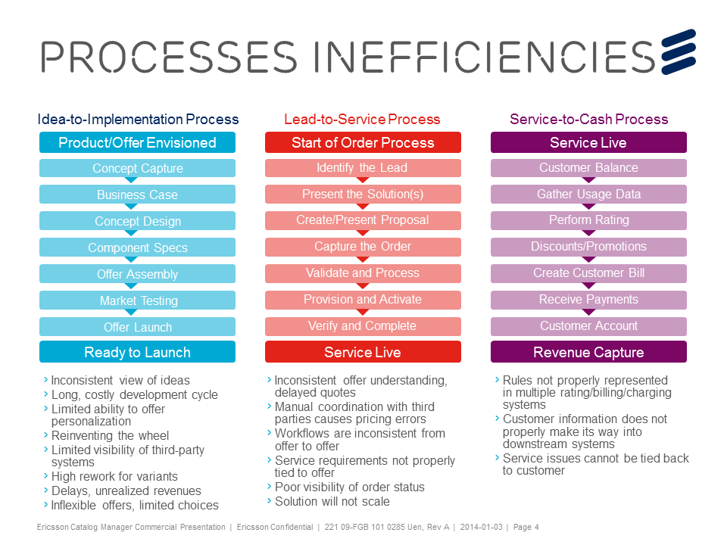

**Figure 2** Typical Business Process Challenges

Idea-to-Implementation reflects the process by which an operator has an idea for a product and implements that product in the marketplace. Ericsson Catalog Manager allows the product team to create and continuously change product offers and their service and resource capabilities in response to a new idea or new technology. Every change in technology is an opportunity to introduce a new product offer.

The Ericsson solution provides the product team a single platform to create standard technical specifications. Each specification is the basis for the creation of new product offerings. Each product offering specifies the characteristics and service/resource requirement to enable a distinct definition of that offering. The solution enables the product portfolio to be managed in one centralized repository for both technical specifications and commercial offers.

Ericsson Catalog Manager is the master of the key data required to determine service availability, supplier availability, Service Level Agreements (SLAs), and costs. In the Lead-to-Order process, it enables assembly of product offerings based on customer choice and recommends a targeted set of suitable offers. A quote is generated and, when approved, Ericsson Catalog Manager connects what is sold to a customer to what is needed for order-to-cash in providing real time information to order management to fulfill the customer order.

In addition, Ericsson Catalog Manager provides a consistent approach and structure for supporting product/service ecosystems involving third parties. It relies upon a centralized catalog that enables third parties to retire their offers, update existing offers with new components, or create new offerings.

In short, Ericsson provides a complete catalog and order management solution on a single pre-integrated platform as shown in the figure below.

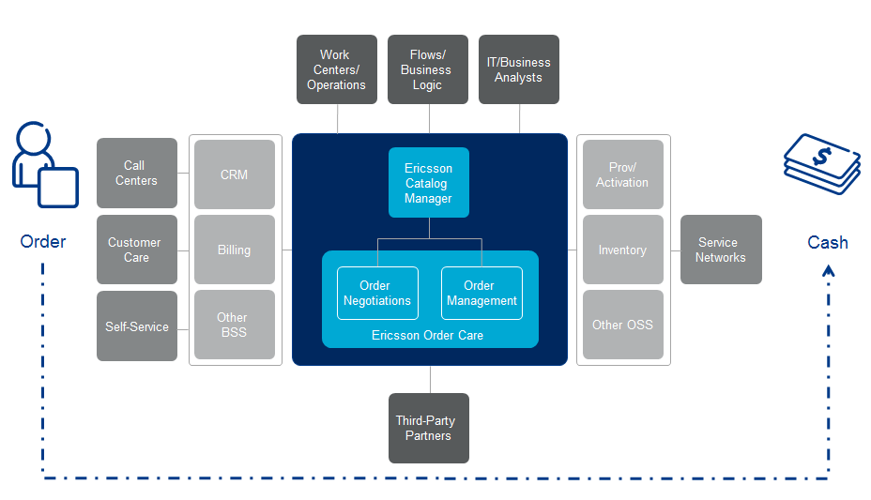

Figure 3: Ericsson Catalog Manager and Ericsson Order Care Functional Architecture

## Customer’s Business Environment

The ability to call on a range of operational process expertise from Ericsson consultants or architects will help to ensure a good fit to customers’ business requirements, as well as any possible structural change or improvements required.

The consulting engagement should be focused on assessing and ensuring the seamless flow of service orders from the point of initiating the order through the entire provisioning process including dispatch and activation. This service also focuses on billing implications, service assurance processes and the work centers and systems that support these processes. Our recommendations and implementation plans ensure flow-through from order negotiation to order completion.

## Pricing Principles

Please refer to the Sales and Ordering process specifically designed for Ericsson products.

# Customer Benefits and Value Argumentation

## Market Message

Ericsson Catalog Manager enables operators to benefit from:

* Reduced time to market for new product offerings
* Reduced time to deliver product offerings to customers
* A centralized catalog that drives federated OSS/BSS/SDP business processes

The following table summarizes the key performance indicators and the value points of Ericsson Catalog Manager for a Tier-1 operator with $35B (in US dollars) in revenues and 15 new product specifications per year.

**Table 4 Ericsson Catalog Manager Value Matrix**

|  | Cost Reduction | Revenue Enablement | Customer Experience | How We Do It |
| --- | --- | --- | --- | --- |
| Reduced Time to Market New Products |  | $11.4M – NPV (recurring) | Reduce Churn  $0.98M – NPV (recurring) | * Accelerate revenue by reducing the time to market with a catalog-driven approach that promotes the reuse of proven product/service/resource components and business process components to systematically turn an idea into a practically realized offering * Reduce the time to architect each third-party relationship by leveraging consistent data, processes and methodologies |
| Reduced Provisioning Interval |  | $2.2M (recurring) |  | * Accelerate revenue by reducing provisioning intervals * Centralized catalog orchestrates processes over disjoint systems |
| Lifecycle Management of New Products | $0.5M |  |  | * Improve the definition, design, development, pricing, marketing and launch of new products with a centralized product/service/resource catalog |
| Lifecycle Management of Existing Products | $0.07M |  |  | * Improve the updating, change  management and versioning of existing products by utilizing a centralized product/service/resource catalog |
| Improved Provisioning | $0.256M |  |  | * Enforce a more consistent structuring of product offers and automation of product selection and fulfilment to reduce errors via cleaner service orders * Adds discipline and structure to processes from offer assembly to activation * Recommend a choice of product offerings with dynamic assembly of the service and resource candidates based on customer criteria |
| **Clean Orders** | $0.308M |  |  | * Less errors due to a common understanding of product/service/resource composition and proper qualification * Increase reliability of fulfilling customer orders by providing structured product/service/resource and process component decomposition data to the downstream order execution systems |

Ericsson Catalog Manager brings consistency to operational data and processes to reduce time to market new services and increase the reliability of fulfilling service orders. It provides a choice of offerings and triggers fulfillment across local and third-party systems.

## Value Argumentation

Ericsson Catalog Manager addresses issues at multiple levels and in multiple groups within an operator. The following table summarizes common entry points and areas of value per main group.

**Table 5** Ericsson Catalog Manager Value by Group Function

| **Group/Function** | **Current Situation** | **Benefits** |
| --- | --- | --- |
| OSS/Operations | Operations organizations are under pressure to support the fulfillment of increasingly complex service orders. Operators are at a competitive disadvantage if new product introductions are delayed because the operations process and systems are not ready or if implementation costs are too high.  There is no consistent approach to automate service provisioning processes. There is no common operational platform in place to handle the various services typically included in today’s operator portfolio. In addition, a portion of an operator’s portfolio may not be offered to customers directly, but rather via suppliers/partners. That means that a service order may be handled by various separate systems, depending on the service mix being requested, making it hard to know who the primary owner of an order is.  The order taking process becomes more complex as services become more sophisticated. Dynamic customization makes this even harder to systemize.  Provisioning best practices are not centrally documented. | * Faster and cheaper order-to-cash of complex offers due to more efficient automation and process orchestration * Reduced operational expenses by re-using components, automating offer assembly – even for the most complex products and bundles * Reduced service order fallout due to a more consistent, well-structured process orchestration and cleaner orders from structured order decomposition * Reduced operational expenses by reusing proven product/service/resource components and invoking/coordinating the most suitable provisioning processes * Higher order-to-cash flow-through by making proven, well-structured components and related provisioning work flows available to third-party service partners |
| Customer Care | Rising customers’ expectations are putting pressure on current order-to-cash platforms – order negotiation in particular. Customers expect fast and reliable delivery of requested product offerings.  The reality is one of the unexpected order processing delays is lack of a consistent understanding of product offers and the ability to choose their own features set. | * Improved customer experience due to the the dynamic selection of product offer features and bundles. Better bundled product offerings with discounts and more reliable commitments, less errors/callbacks, with on-time delivery * Meet or exceed customer expectations due to a more robust product offering selection process that provides more choices to customers that are consistent with downstream provisioning systems * Qualified product requests – against existing inventory |
| BSS/Marketing/Product Management | Most operators employ configurable COTS packages that improve time to market, but still these packages need to be updated individually – the pre-ordering, ordering, and fulfilment processes are driven by disjoint systems, coordinated only through the efforts of IT, business and operations staff.  When products include third-party components, the time to architect, integrate and support each “relationship” is handled as a “project within a project.” The challenge is to deal with these ecosystems, either retail or wholesale, in a timely fashion to avoid excessive delays in generating revenues.  Operators are also trying to figure out how they can support a third-party retail model without having to make configuration changes apparent to the third party. Third parties selling services for an operator do need the product information, its feature list and the price in order to make the sale. The operator is responsible to provide the product offering as described.  Operators are faced with many new retail opportunities through many new channels. However, the sales, product management and marketing teams are struggling with slow speed to market, rigid product structures that are difficult to change to meet new requirements, and cumbersome distribution of product information through multiple channels. | * Increased speed to market new services by providing a common nomenclature across the business for products and its definitions, and by enforcing consistency in the underlying processes across multiple provisioning systems * Increased customer satisfaction through a centralized platform that enables consistent support for products including related pre-order, order, and fulfillment processes * Reduced service creation costs by promoting component reuse * Flexible product structures to quickly meet new customer requirements * Well-structured distribution of product information across different domains, systems and channels * Reduced time to architect each third-party relationship by leveraging common data, processes and methodologies with the proper access restrictions * Reduced time to respond to changing needs when dealing with third-party service partners * Reduced time to market and cost of a new product introduction as a result of the product lifecycle management (PLM) functionality |
| IT | Customizing currently deployed provisioning platforms is labor-intensive – usually involving long lead times. Specialized knowledge and development tools are required to run and maintain these platforms as well as the associated middleware. It takes too long to develop provisioning capabilities to support a new device or service. It takes too long to modify these platforms when there is a service request change.  Most operators need to update their downstream systems individually – the provisioning processes are supported by disjoint systems, coordinated only through the efforts of IT, business and operations staff.  Operators are faced with pressures to cost-effectively integrate with third-party partners. | * Provides a platform for data and process consolidation * Automates most of the service ordering process – from order to activation * Increased speed to market for new products by providing a common nomenclature across the business for products/services/resources and their definitions, and by enforcing consistency in the underlying data and processes * Reduced OSS development and updating costs via flexible modeling and consistent methodologies that promote fast service redesign and better coordinated order fulfillment * Reduced BSS development and updating costs by supplying a centralized platform that documents product offerings and makes product recommendations and quotes * Reduced OSS development/updating and third-party integration costs  via service component reuse,  flexible modeling, and a consistent, well-structured view of products/services/resources and underlying provisioning processes across internal and third-party systems |

## Business Case

The return on investment (ROI) for improving product/service introduction varies depending on the size of the operator, number of products, and the size of the existing product team. As shown in the following figure, this ROI also depends upon the operator’s timeline for new product development, for BSS/OSS updates and for network provisioning.

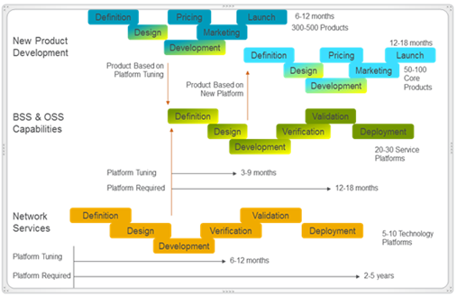

**Figure 4** Operator’s Timeline Considerations

As a ROI example, let’s consider an operator with the following characteristics:

* Tier-1 operator with $35B (US dollars) in total revenues
* New product revenue is 1% of total revenue
* Business Services revenues is 12% (this business case utilizes business services as a basis for analysis)
* 15 new products/year

This operator may need to generate or maintain 300 product ideas to be able to take 20% of those ideas to the product concept phase to determine if the product is feasible and gain approval to design and develop the product. By using Ericsson Catalog Manager this operator might see a reduction in product management staff, domain expertise and system liaison as shown in the following figure.

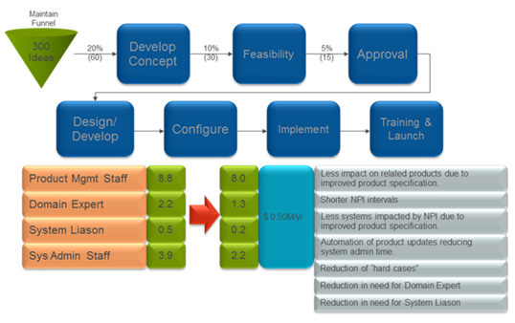

**Figure 5** ROI for New Product

By consistently using a Service Factory approach, the operator can realize improvements in the key performance indicators (KPI) listed in the following table, resulting in either revenue increase or cost savings.

**Table 6** Improvements in KPIs

|  |  |  |  |
| --- | --- | --- | --- |
| **KPI** | **Revenue Increase** | **Cost Savings** | **Notes** |
| Accelerated revenue –  new product introduction | $11.4M – NPV |  | Recurring |
| Accelerated revenue – reduced provisioning interval | $2.2M |  | Recurring |
| Lifecycle management for existing products |  | $0.07M |  |
| Lifecycle management for new products |  | $0.5M |  |
| Reduce churn | $0.98M – NPV |  | Recurring |
| Improved provisioning |  | $0.256M |  |
| Clean orders |  | $0.308M |  |

# Sales Approach

## Sales and Differentiation Strategy

Ericsson Catalog Manager provides a strong, cohesive foundation for:

* Idea to Implementation
  + Centralizes the definition of new products
  + Models products/services/resources in a flexible way to allow for upstream product recommendations and downstream order decomposition/execution for fulfillment, assurance and billing
  + Allows the reuse of existing product/service/resource and process components to build new commercial offers
  + Supports all product lines, markets and geographic areas
* Order to Cash
  + Supports any complex service orders by decomposing them into product/service/resource and process components
  + Orchestrates instructions to enable multi-play provisioning over silo’ed provisioning stacks

Ericsson Catalog Manager structures new products and order-to-cash automation – extensible modeling and a product assembly approach based upon consistent processes and methodologies to promote reuse, fast design and improved order fulfillment.

Ericsson provides a centralized catalog to support offer creation, pre-ordering, and ordering processes and a methodology for creating federated order-to-cash processing. Catalog data not only promotes component reuse when creating offers, but also ties these components to the corresponding work flows and sub-flows. As a result, Ericsson Catalog Manager can be used in combination with Ericsson Order Care in order negtiations and order management to drive the implementation of order-to-cash process flows.

Ericsson Catalog Manager benefits from the broadest/deepest telecom OSS expertise to implement a catalog-driven approach across fulfillment for pre-order, order validation, order management, inventory assignment, activation, assurance and billing. It bridges idea-to-implementation with order-to-cash processes to provide comprehensive qualification of dynamically assembled offerings and reduced time-to-revenue and service order fallout.

## Customer communication

### If you only have 10 seconds, say this:

Is your OSS/BSS capable of supporting the business change or development programs you are looking to execute?

Are you dealing with:

* Inability to meet market demands for new product offers?
* Rigid inflexible product offerings with limited customer choices and static price models?
* Low or no ability to dynamically assemble product recommendations based on customer entered input or requirements?
* Re-inventing the wheel every time a new product offering is introduced?
* High rework to realize offer variants? High service order rework?
* Unrealized revenues due to delays?
* Inconsistent understanding of offers; delayed quotes?
* Slow, manual order handling? Unattainable levels of automation?

Ericsson Catalog Manager centralizes product/service/resource specifications to assemble offers, via component reuse, and orchestrate service fulfillment. It gives you the **consistency** needed, in terms of operational structure and discipline, to reduce the time to market new services and increase the reliability of fulfilling service orders.

### If you have 10 minutes, say this:

Ericsson Catalog Manager provides a centralized product/service/resource catalog platform that:

* Applies a service factory approach to assemble new product offers from technical specifications that facilitate component reuse.
* Allows CSRs to find unique customer solutions via an automated product selection search engine and to trigger fulfillment across OSS/BSS and third-party systems.
* Drives the coordinated provisioning of multi-vendor third-party product offerings including the ability of third parties to retire, update or add new offer components.
* Facilitates innovation by enabling differentiated offer types (exposing services/resources or APIs) for both retail and wholesale.
* Federates service provisioning processes.

Ericsson Catalog Manager adds discipline and structure to processes from idea to activation to dynamically assemble offerings and orchestrates fulfillment.

### If you have one hour, say this:

In a longer presentation, Sales Rep should cover:

* The market trends
* The impact on operator's business operations, in particular in the effect on current mode of operations in idea-to-implementation and order-to-cash
* The realizable potential for improvements in these areas, based on customer examples
* Explanation of Ericsson Catalog Manager as it relates to the TMF Frameworx and SID model.

## Sales activities

Ericsson should work with customers to offer the best value.

This begins with acquiring a detailed understanding of the customer’s situation via a series of customer interaction sessions. These sessions are basically a dialog about specific customer business needs and challenges in light of the most influential market trends. To keep the interaction focused, this dialog should be framed in terms of operational process areas – plan-to-provision, order-to-service, and trouble-to-resolution – and the specific key performance indicators that are driving the customer’s business case.

Once this understanding is achieved, subsequent sessions can then focus on how Ericsson can positively impact the customer’s business case as per the guidelines outlined earlier. This should be supported by a customized value proposition. The goal of these customer interaction sessions is to come up with an Ericsson solution (software and services) that best supports the customer’s current and future business plans.

Further activities could include demonstrations and proof-of-concept trials that best illustrate actual benefits and value.

## Tactical Aspects

The Sales Team should have the following tactical aspects in mind.

* Ericsson has the broadest and deepest OSS/BSS portfolio in the industry.
* Ericsson offers a balanced, phased approach that enables customers to buy only what they need when they need it.
* Solutions can accommodate partnering where it makes business sense.
* Comprehensive customer training is available.
* Besides providing productized, integrated systems with predefined templates and workflows, Ericsson offers extensive best practice experience to mitigate customization costs and time.
* Solutions can be customized to address specific organizational changes within the customer's enterprise.

# Customer Project Approach

As shown in the following figure, there are various steps in the proper implementation of Ericsson Catalog Manager. The results from these steps provide the business and procedural logic and data needed to configure the Catalog including the creation of product, service, and resource specifications.

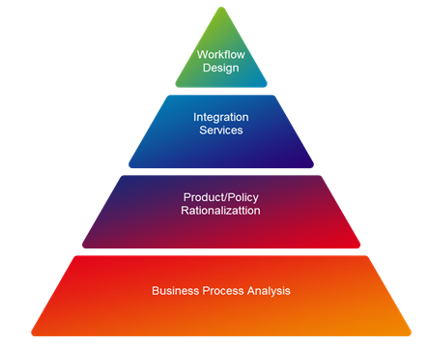

**Figure 6 Implementation Steps**

A typical project should be staffed with appropriate levels of customer-facing personnel to participate in requirements gathering and in the creation of specifications and interfaces.

A project might take from three months to one year depending on the complexity of the interfaces involved and number of products to be implemented.

A typical project also involves integrating Ericsson Catalog Manager with OSS/BSS systems. Ericsson Catalog Manager is already pre-integrated with Ericsson Order Care and Ericsson Charging and Billing in One. Additional integrations typically requires close coordination with the service provider’s staff to properly model the BSS-level products and the OSS-level services and resources.

**Rationalization/Normalization of Data**

To improve the management of product/service/resource data and leverage Ericsson Catalog Manager capabilities, Ericsson can provide a rationalized set of products using a consistent modeling approach that enables repeatable business operations.

Ericsson experts work with the customer by gathering existing product model data, analyzing the data, and grouping the information into appropriate categories. Redundant data are removed and the data are normalized to create standardized product models.

# Competitive Situation

Our primary competitors are:

**Amdocs**

* Extensive services work and up-scoping required to successfully implement
* Poorly integrated product, service, and resource catalogs

**Tribold (acquired by Sigma Systems)**

* Single product, small company with limited sales team
* Solution still requires many manual processes
* No other OSS/BSS products – likely target for buy-out
* Under the hood there is a lot of reliance on spreadsheets, Microsoft Access, and SQL
* Tribold does have reference customers

**Convergys (acquired by NEC which owns NetCracker)**

* Convergys Enterprise Product Management is a static catalog queried by billing and CRM systems
* Convergys’ portfolio strength lies in their billing, rating, mediation and revenue assurance products
* NEC has acquired the piece parts necessary to compete in the end-to-end fulfillment space – solution is not yet integrated

**CISCO (acquired Comptel Active catalog)**

* This is the first catalog to allow for product/service assembly